

LICENSING ACT 2003
Premises Licence Summary

Home Bargains

Part One – Premises Details

Postal address of premises, or if none, ordnance survey map reference or description

Home Bargains, 26-27 George Street, Tamworth, Staffordshire, B79 7LL

Post Town Tamworth | Post Code B79 7LL
Telephone number 01827 310390

Where the licence is time limited the dates

This licence is not time limited

Licensable activities authorised by the licence

Supply of Alcohol (Off Sales)
Opening hours

The times the licence authorises the carrying out of licensable activities

Supply of Alcohol (Off Sales)
 | From | To
Sunday | 08:00 | 22:00
Monday | 08:00 | 22:00
Tuesday | 08:00 | 22:00
Wednesday | 08:00 | 22:00
Thursday | 08:00 | 22:00
Friday | 08:00 | 22:00
Saturday | 08:00 | 22:00

The times the licence authorises the carrying out of licensable activities

Opening hours
 | From | To
Sunday | 08:00 | 22:00
Monday | 08:00 | 22:00
Tuesday | 08:00 | 22:00
Wednesday | 08:00 | 22:00
Thursday | 08:00 | 22:00
Friday | 08:00 | 22:00
Saturday | 08:00 | 22:00

Where the licence authorises supplies of alcohol whether these are on and/or off supplies

Off the premises

Part Two

Name, (registered) address of holder of premises licence

TJ Morris Limited , Home Bargains
Axis Business Park, Portal Way, Gillmoss, Liverpool, L11 0JA

Telephone - 0151 530 2920

Registered number of holder, for example company number, charity number (where applicable)

1505036

Name of designated premises supervisor where the premises licence authorises the supply of alcohol

Mr Benjamin William Brant

State whether access to the premises by children is restricted or prohibited

Not restricted or prohibited

Dated this 30th June 2023

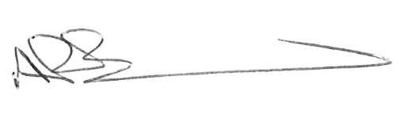
Andrew Barratt
Chief Executive

Paul Holmes
___________________________________
Countersigned:

Address to which all communication should be sent:

Licensing, Public Protection

Tamworth Borough Council, Marmion House, Lichfield Street, Tamworth, B79 7BZ

Tel 01827 709445 or Fax 01827 709434

