

LICENSING ACT 2003
Premises Licence Summary

Kettlebrook News and Off Licence

Part One – Premises Details

Postal address of premises, or if none, ordnance survey map reference or description

Kettlebrook News and Off Licence
29 Cross Street, Kettlebrook, Tamworth, Staffordshire, B77 1AS

Post Town Tamworth | Post Code B77 1AS
Telephone number Not known

Where the licence is time limited the dates

This licence is not time limited

Licensable activities authorised by the licence

Supply of Alcohol (Off Sales)
Opening hours

The times the licence authorises the carrying out of licensable activities

Supply of Alcohol (Off Sales)
 | From | To
Sunday | 10:00 | 22:30
Monday | 08:00 | 23:00
Tuesday | 08:00 | 23:00
Wednesday | 08:00 | 23:00
Thursday | 08:00 | 23:00
Friday | 08:00 | 23:00
Saturday | 08:00 | 23:00
Good Friday 08:00 to 22:30
Christmas Day 12:00 to 15:00 and 19:00 to 22:30

The times the licence authorises the carrying out of licensable activities

Opening hours
No restriction

Where the licence authorises supplies of alcohol whether these are on and/or off supplies

Off the premises

Part Two

Name, (registered) address of holder of premises licence

Sri Valli Garages Ltd
9 Corbett Chase, Gedling, Nottingham, NG4 4LU

Telephone – Not Known

Registered number of holder, for example company number, charity number (where applicable)

12334956

Name of designated premises supervisor where the premises licence authorises the supply of alcohol

Mr Sathishkumar Sengodan

State whether access to the premises by children is restricted or prohibited

Not restricted or prohibited

Dated this 09th November 2022

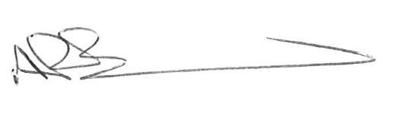
Andrew Barratt
Chief Executive

Paul Holmes
___________________________________
Countersigned:

Address to which all communication should be sent:

Licensing, Public Protection

Tamworth Borough Council, Marmion House, Lichfield Street, Tamworth, B79 7BZ

Tel 01827 709445 or Fax 01827 709434

