LICENSING ACT 2003
Premises Licence Summary

Tamworth Co-operative Society Limited

Part One – Premises Details

Postal address of premises, or if none, ordnance survey map reference or description

Tamworth Co-operative Society Limited
1-5 Church Street, Tamworth, Staffordshire, B79 7DH

Post Town Tamworth | Post Code B79 7DH
Telephone number 01827 63711

Where the licence is time limited the dates

Not applicable

Licensable activities authorised by the licence

Supply of Alcohol (Off Sales)

The times the licence authorises the carrying out of licensable activities

Supply of Alcohol (Off Sales)
 | From | To
Sunday | 10:00 | 22:30
Monday | 08:00 | 23:00
Tuesday | 08:00 | 23:00
Wednesday | 08:00 | 23:00
Thursday | 08:00 | 23:00
Friday | 08:00 | 23:00
Saturday | 08:00 | 23:00
Non Standard Timings

Good Friday 08:00 - 22:30
Christmas Day 12:00 - 15:00 and 19:00 - 22:30

Where the licence authorises supplies of alcohol whether these are on and/or off supplies

Off the Premises

The opening hours of the premises
No restriction

Part Two

Name, (registered) address of holder of premises licence

Tamworth Co-operative Society Limited
5 Colehill, Tamworth, Staffordshire, B79 7HE

Telephone – 01827 63711

Registered number of holder, for example company number, charity number (where applicable)

IP02582R

Name of designated premises supervisor where the premises licence authorises the supply of alcohol

Julie Clark

State whether access to the premises by children is restricted or prohibited

Not restricted or prohibited

Dated this 01st August 2023

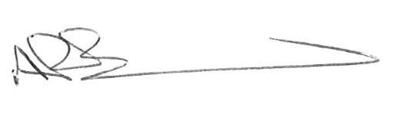
Andrew Barratt
Chief Executive

Paul Holmes
___________________________________
Countersigned:

Address to which all communication should be sent:

Licensing, Public Protection, Assets & Environment,

Tamworth Borough Council, Marmion House, Lichfield Street, Tamworth, B79 7BZ

Tel 01827 709445 or Fax 01827 709434

