

LICENSING ACT 2003
Premises Licence Summary

Tudor House Cafe

Part One – Premises Details

Postal address of premises, or if none, ordnance survey map reference or description

Tudor House Cafe
111 Lichfield Street, Tamworth, Staffordshire, B79 7QB

Post Town Tamworth | Post Code B79 7QB
Telephone number Not known

Where the licence is time limited the dates

This licence is not time limited

Licensable activities authorised by the licence

Supply of Alcohol (On Sales)
Opening hours

The times the licence authorises the carrying out of licensable activities

Supply of Alcohol (On Sales)
 | From | To
Sunday | 12:00 | 21:30
Monday | 12:00 | 21:30
Tuesday | 12:00 | 21:30
Wednesday | 12:00 | 21:30
Thursday | 12:00 | 21:30
Friday | 12:00 | 21:30
Saturday | 12:00 | 21:30

The times the licence authorises the carrying out of licensable activities

Opening hours
 | From | To
Sunday | 09:30 | 22:00
Monday | 09:30 | 22:00
Tuesday | 09:30 | 22:00
Wednesday | 09:30 | 22:00
Thursday | 09:30 | 22:00
Friday | 09:30 | 22:00
Saturday | 10:00 | 22:00

Where the licence authorises supplies of alcohol whether these are on and/or off supplies

On Sales

Part Two

Name, (registered) address of holder of premises licence

Lisa Bonser
295 Wilnecote Lane, Belgrave, Tamworth, Staffordshire, B77 2LF

Telephone – Not known

Registered number of holder, for example company number, charity number (where applicable)

Not applicable

Name of designated premises supervisor where the premises licence authorises the supply of alcohol

Lisa Bonser

State whether access to the premises by children is restricted or prohibited

Access is not restricted or prohibited

Dated this 21st April 2023

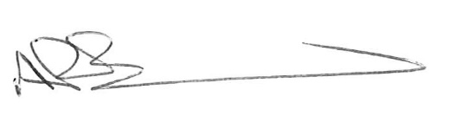
Andrew Barratt
Chef Executive

Paul Holmes
___________________________________
Countersigned:

Address to which all communication should be sent:

Licensing, Public Protection

Tamworth Borough Council, Marmion House, Lichfield Street, Tamworth, B79 7BZ

Tel 01827 709445, Email publicprotection@tamworth.gov.uk, or Fax 01827 709434

